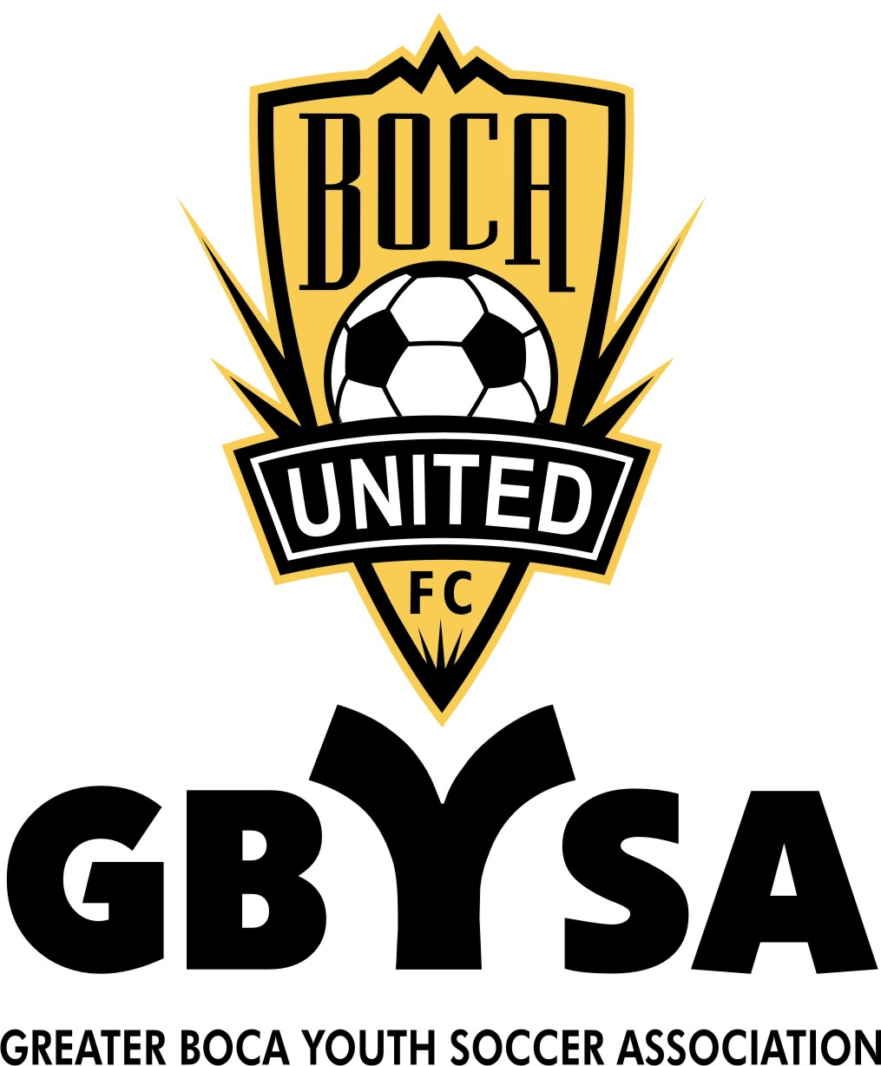
Dear Sponsor:

Greater Boca Youth Soccer Association Inc. is a not-for-profit organization which oversees a full range of youth soccer programs in West Boca. GBYSA/Boca United FC is administered entirely by volunteers; none of the officers are compensated for their time. Each year, GBYSA looks to community leaders like you, to help ensure the success of our programs by sponsoring. This sponsorship option is available if a player is unable to meet his/her financial commitment to join a team and a person or business would like to Sponsor an Individual Player in full or in part. A basic, tax-deductible sponsorship fee of

Sponsor a Child BU9 thru BU14 for $1,450 or any part of

Sponsor a Child BU15 thru BU18 for $1,250 or any part of

Sponsor a Child Academy / Pre Academy for $1,950.00 or any part of

You will be listed in our directory and
on our Website with a link to your site
Our cooperation in distributing your flyers, coupons or other information about your business to our players and their families. An invitation to the awards ceremony at the end of the season.

GBYSA/Boca United FC offers a wide range of additional sponsorship opportunities, sponsor acknowledgements depending on contribution level. For details, please visit the GBYSA Web site www.gbysa.org or contact the Director of Sponsorship at gbysa_funding@gbysa.org. If you would like to be a GBYSA/Boca United FC sponsor, please complete the information below and mail this form with a check, payable to GBYSA:

GBYSA/Boca United FC Sponsor, PO Box 880544, Boca Raton, FL 33488-0544.

Players Name :
Team Age U- Boys Girl
Sponsor Name:
Sponsor Contact Person at Business:
Sponsor Address:
Sponsor Telephone :( ) - E-mail:
Amount Sponsored:
Visit our Web site www.gbysa.org
Greater Boca Youth Soccer Association is a registered 501(c)(3) non-profit organization. All donations are tax-deductible to the extent allowed by law. A copy of the official registration and financial information may be obtained from the Division of Consumer Services by calling toll-free (800-435-7352) within the state. Registration does not imply endorsement, approval, or recommendation by the state.

